**Date of preparing: 20/09/2022**

**Date of teaching: 27/09/2022**

**Tên chuyên đề:**

*“Một số hoạt động nhằm khuyến khích học sinh tương tác trong các giờ học tiếng Anh”*

**PERIOD 9: READING ON HEALTHY LIVING**

**I. Objectives**

- By the end of the lesson, SS will be able to

+ Practice reading about health tips

+ Practice giving advice on some health problems

*1. Knowledge*

- SS learn about some health tips in daily life

*2. Skill:* Reading skill

3. *Attitude*:

- Positive attitude on health problems

- Have good life skills

4. *Competence*:

- Co-operation: Group work, Pair work, Team work

- Self – study: Individual work

- Using body language

**II. Preparation**

1. Teacher: computer, projector
2. Students: handout, notebooks

**III. Teaching methods:**

* Communicative approach
* Teaching methods with games, visual aids, group discussion…

**IV. Procedure (45’)**

|  |  |  |
| --- | --- | --- |
| **Stages/Time** | **Teacher and students’ activities** | **Interaction** |
| **WARM-UP**  **(5’)** | **\* Aims: to revise some vocabulary and warm up the class**  - **Content**: SS match the correct words with the pictures  - **Outcome**: SS recall some words about health problems  - **Organization**: Individual work – Group work  **\*Match the words with the pictures about health problems**  **a. sunburn b. flu**  **c. overweight d. tired**  **e. spot**     1. 2.   **Overweight boy eating ice cream cute chubby child Vector Image** Free Vector | Cartoon oily skin illustration with man  **3. 4. 5.** | - SS works individually and find the answers  - T: check SS’ answers and give feedbacks  1 – b  2 – a  3- d  4 – c  5 – e  -SS: follow the instructions of T  -T: Listen and check SS’ presentation |
| **\* Extra activity: Number decoding**  **- Aim:** Help SS to remember the words  - **Content**: Read the words with the number codes  - **Outcome**: SS can remember the words  **- Organization:** Group work **–** Individuals  + T read different codes from easy to difficult ones  + SS listen and say list of words  *Ex: 1123: flu – flu – sunburn – tired*  ***\* Lead in the reading lesson about Health tips*** |
| **NEW LESSON**  **5 mins**  **5 mins**  **10 mins**  **5 mins**  **5 mins**  **WRAP-UP**  **(8 mins)** | **\*Pre – reading**  **\* Pre-teach vocabulary**  **- Aim:** to helps SS understand some new words before reading the text  - **Content**: Introduce some new words in the text  **- Outcome:** SS know the meaning, pronunciation and word stress  - **Organization**: Individual work  **I. NEW WORDS**  **- heart disease (n)** /ˈhɑːt dɪˌ’ziːz/: bệnh tim  **- keep fit (v)** /ˌkiːpˈfɪt/ : giữ (cơ thể) cân đối  **- at the risk of (v)** /ət ðə rɪsk ov/ : có nguy cơ mắc…  Ex: We are at the risk of heart disease.  **- prevent (…from…)** /prɪˈvent frəm/ : ngăn chặn (…khỏi…)  Ex: Clean hands prevent us from flu**.**  **\* Check Vocabulary: Safari**  - Put 4 new words with 4 animals and place these animals in 4 corners of the class  - SS have to remember the words attached to 4 animals to play the game  - T says the name of animal or Vietnamese meanings, SS say aloud the words in 3 steps  + Point and say word in English  + Take photos and say word in English  + Selfie and say Vietnamese meaning   * Each group has a student to observe other groups to find the winner with correct actions and correct words   * T shows 4 statements in task 1 and let SS guess the answer  - Then ask SS to read the text and do Task 1  **\* While - Reading**   * **Aim:** to help SS know some tips about heath * **Content:** SS read the text and complete task 1 (T/F) and task 2 (Gap-filling) * **Outcome:** SS can have some knowledge about how to keep them healthy * **Organization:** Individual work – Pair work – Group work   **II. READING**  **Task 1: Read the health tips and tick T/F**     |  |  |  | | --- | --- | --- | | **Statements** | **T** | **F** | | 1. We should eat much sugar and salt. |  |  | | 2. Doing exercise or sports keeps us fit and active. |  |  | | 3. It’s not a good idea to stand up and walk around every hour during your sitting and screen time. |  |  | | 4. Cleaning our hands regularly is a way to prevent some diseases. |  |  |   **Task 2: Read the health tips again and complete each statement (1 - 6) with ONE word from the text.**  1. Eating a lot of salt or sugar can cause___________ disease.  2. Drinking only _____________ water.  3. Doing some _____________ activities such as sports and housework.  4. Standing up every hour and exercising your ____________ to reduce sitting time.  5. Your mind works well if you get enough good ___________.  6. ______________ regularly to prevent some diseases.    **\* Extra activity: Upside down**  **- Aim:** to make a more challenging activity for SS and help SS to remember what they have done in Task 2  **- Content:** SS look at the sentences in rotated form and read aloud them with the correct word for each blank  **- Outcome:** SS have the second chance to remember some health tips  **- Organization:** Pair work – Group work  - T introduces the rules and asks SS to practice in pairs, then compete in groups  + SS wheel the circle and choose the number of the sentences to read aloud.  + Each group has 2 volunteers to play  + The student who can read correctly will spin the wheel to get stars for his/her group    **\*Post - Reading**  **Task 3: Look at the picture and retell the tips**  **Aim:** to helps SS recall what they have learned in the lesson  **Content:** SS look at the pictures and retell some tips  **Outcome:** SS can remember some health tips thoughtfully  **Organization:** Pair work – Individual work   * T shows 6 pictures of 6 tips that SS have learned and asks them to retell in pairs, then T calls some students to choose a tip to talk about     **Task 4: Guess the health problems and give advice**  **\* MIME GAME**  **Aim:** to helps SS think of their own problems and give some advice  **Content:** Some SS use their body language to describe the problems. Other students name the problems and ask for advice  **Outcome:** SS can develop their creativity  **Organization:** The whole class | * Image * Image * Translation * Translation * Group work * SS: practice * T: observe and give feedback * SS: work in pairs and guess T/F for Task 1   - SS: work individually, the compare the answer with their friends  - T: check the answer and give feedback  **\* Key**  1. F 2. T  3. F 4. T  -  SS: practice in pairs and find the answer  - T: remind SS to choose only one word  - T: check SS’ answers  **\* Key**  1. heart  2. safe  3. physical  4. eyes  5. sleep  6. Handwash  SS: Listen and follow T’s instructions  TT: Check SS’ presentation  SS: Practice in pairs, then volunteer to retell the tips  T: Listen and ask other SS to make comments and guess which tip their friend is talking |
|  | * T calls some volunteers to perform their body language  * SS look and say the health problems, then make a question to ask other SS how to deal with these problems | SS: practice  T: observe and comment |
| **HOMEWORK**  **(2 mins)** | * Learn new words   + Write each new word in 3 lines  + Practice reading aloud these words correctly  + Make 4 sentences with 4 new words   * Write 4 tips to prevent viruses, using “should/shouldn’t”   *Ex: We should wear mask in crowded places.* | SS: write down homework and listen to T’s instructions |

**Remarks:**

………………………………………………………………………………………………………………………………………………………………………………………………………………………………………………………………………………………………

**Student’s name: ………………………………….**

**Class: ……………………………………………..**

**STUDENTS’ HANDOUT**

**HEALTH TIPS**

a. Eat less salt and sugar. They put us at the risk of heart disease.

b. Drink enough water, about one and a half liters a day. Make sure that you are drinking safe water. Unsafe water can lead to many kinds of diseases.

c. Do more physical activities like sports and housework. It helps keep you fit and active.

d. Reduce sitting and screen time. Standing up every hour and doing some simple exercise or walking around are good choices. Exercise your eyes too.

e. Get seven to eight hours of good sleep each night. This helps both your mind and body work well

f. Handwash regularly with soap and water. Clean hands help prevent us from the

spread of some diseases.

**Task 1: Read the health tips and write T/F**

|  |  |  |
| --- | --- | --- |
| **Statements** | **T** | **F** |
| 1. We should eat much sugar and salt. |  |  |
| 2. Doing exercise or sports keeps us fit and active. |  |  |
| 3. It’s not a good idea to stand up and walk around every hour during your sitting and screen time. |  |  |
| 4. Cleaning our hands regularly is a way to prevent some diseases. |  |  |

**Task 2: Read the health tips again and complete each statement (1 - 6) with ONE word from the text.**

1. Eating a lot of salt or sugar can cause___________ disease.

2. Drinking only _____________ water.

3. Doing some _____________ activities such as sports and housework.

4. Standing up every hour and exercising your ____________ to reduce sitting time.

5. Your mind works well if you get enough good ___________.

6. ______________ regularly to prevent some diseases.

**Task 3: Look at the pictures and retell 6 health tips**

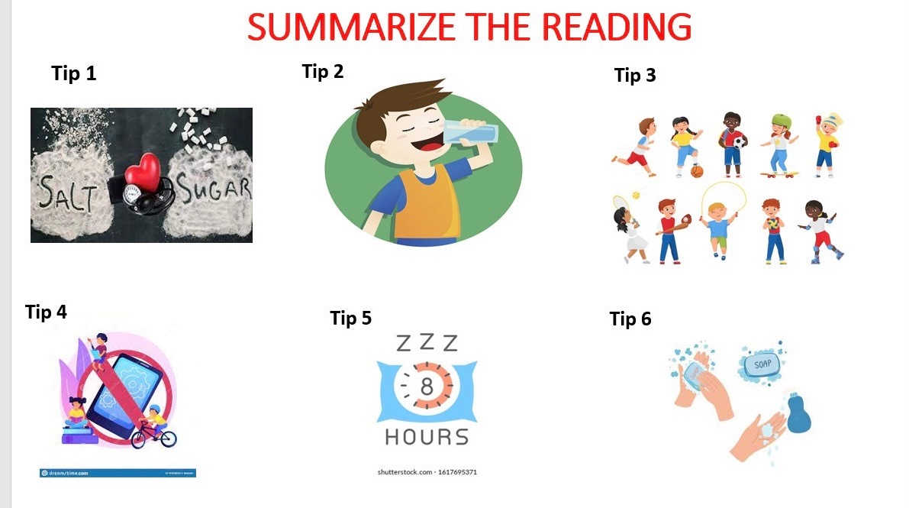

**Task 4: Guess the health problems and give advice**

………………………………………………………………………………………………………………………………………………………………………………………………………………………………………………………………………………………………………………………………………………………………………………………………

***--- The end ---***